DATA ANALYTICS INTERNSHIP — PROJECT 5
Finance Analysis
Stock Market Performance, Portfolio & Risk Assessment
Domain: Finance | Option 5 | 6 Indian Stocks | 5 Years (2020–2024)
7,500 Records  Daily OHLCV data | 6 Stocks  NSE large-cap | 5 Years  2020–2024
Tools: Python | Pandas | Matplotlib | NumPy | SciPy
Sections: Project Overview | Setup Instructions | Code Structure | Visual Documentation | Technical Details | Testing Evidence

1. Project Overview
Project Title
Finance Analysis: Stock Market Performance, Portfolio Optimisation & Risk Assessment

Goal
Analyse 5 years of daily stock price data for 6 major Indian NSE companies to identify price trends, measure volatility, compute technical indicators, and assess portfolio risk to help investors make data-informed decisions.

Business Problem
Individual and institutional investors lack tools to systematically compare stock performance, quantify risk, and identify technical signals. This project answers: Which stocks gave best returns? When were optimal entry points? How should an investor allocate capital across these 6 stocks?

Objectives
- Track daily closing price trends and calculate cumulative 5-year returns per stock
- Compute daily returns and measure volatility using rolling standard deviation
- Build technical indicators: Moving Averages (MA20, MA50), RSI, and Bollinger Bands
- Identify Golden Cross and Death Cross trading signals on price charts
- Measure pairwise correlations between all 6 stocks
- Calculate Sharpe Ratio for risk-adjusted return comparison
- Model equal-weight portfolio and compare against individual stock performance

Dataset Summary
Metric | Value
Total Records | 7,500 daily trading records
Companies | TCS, Infosys, HDFC Bank, Reliance Industries, Wipro, ITC
Date Range | January 2020 to December 2024 (5 years, ~250 trading days/year)
Raw Columns | Date, Open, High, Low, Close, Volume, Company
Derived Columns | daily_return, cumulative_return, MA20, MA50, RSI, Bollinger Bands, rolling_vol
Missing Values | Zero — all trading days present for all 6 stocks
Risk-Free Rate | 6% per annum (Indian government bond yield)
Best Performer | TCS — highest 5-year cumulative return

2. Setup Instructions
Step 1 — Check Python Version
python --version (requires Python 3.8 or above)

Step 2 — Install Required Libraries
pip install pandas numpy matplotlib scipy

Step 3 — Verify Installation
python -c "import pandas, numpy, matplotlib, scipy; print('All libraries ready')"

Step 4 — Folder Structure
Project5_Finance_Analysis/
stock_prices.csv
Project5_Finance_Analysis.ipynb

Step 5 — Launch Jupyter
pip install notebook
jupyter notebook

Step 6 — Run All Cells
Open Project5_Finance_Analysis.ipynb. Click Cell menu → Run All. All 8 charts appear inline.

3. Code Structure
Dataset Column Reference
Column | Description
date | Trading date (datetime type)
company | Company name — one of 6 NSE stocks
open | Opening price of the session in Rupees
high | Highest intraday price
low | Lowest intraday price
close | Closing price — used for all analysis
volume | Shares traded during the session
daily_return | % change from previous day close (derived)
cumulative_return | Compounded total return from Day 1 (derived)
MA20 | 20-day rolling moving average of close (derived)
MA50 | 50-day rolling moving average of close (derived)
RSI | 14-day Relative Strength Index — 0 to 100 scale (derived)
upper_band | Bollinger upper band: MA20 + 2 × rolling std (derived)
lower_band | Bollinger lower band: MA20 − 2 × rolling std (derived)
rolling_vol | 30-day rolling std of daily returns (derived)

Notebook Cell Structure
Cell | Purpose
CELL 1 | Import libraries, stock colour map, global matplotlib settings
CELL 2 | Load dataset, date range, company list, basic descriptive stats
CELL 3 | Data quality: OHLCV validation, missing trading days check
CELL 4 | KPIs: best/worst performer, avg return, max drawdown summary
CELL 5 | Calculate daily returns using pct_change() per company
CELL 6 | VIZ 1: Normalised price trends — all 6 stocks (base index 100)
CELL 7 | Cumulative return calculation using cumprod()
CELL 8 | VIZ 2: Cumulative return lines — growth of Rs.100 over 5 years
CELL 9 | Moving average calculation: MA20 and MA50 per stock
CELL 10 | VIZ 3: Price chart with MA20 & MA50 + Golden/Death Cross signals
CELL 11 | RSI calculation (14-day avg gains vs losses)
CELL 12 | VIZ 4: RSI indicator chart with overbought/oversold bands
CELL 13 | Bollinger Bands calculation (MA20 ± 2σ)
CELL 14 | VIZ 5: Bollinger Bands price chart with shaded band area
CELL 15 | Rolling volatility (30-day std) calculation per stock
CELL 16 | VIZ 6: Rolling volatility comparison — all 6 stocks
CELL 17 | Correlation matrix and Sharpe Ratio calculation
CELL 18 | VIZ 7: Pairwise correlation heatmap + Sharpe Ratio bar chart
CELL 19 | Equal-weight portfolio simulation and maximum drawdown
CELL 20 | VIZ 8: Portfolio vs individual stocks + max drawdown comparison
CELL 21 | Investment recommendations and risk summary
CELL 22 | Final stock performance ranking table

4. Visual Documentation
All 8 charts generated with pure matplotlib. No external image files required. Financial indicators computed from raw OHLCV data.

VIZ 1 — Normalised Stock Price Trends — All 6 Stocks (Base = 100)
Chart Type: Multi-line chart | All stocks normalised to 100 on Day 1 | COVID crash zone highlighted
Code: norm = prices / prices[0] * 100 per stock. ax.plot(years_x, norm) per company. axvspan for COVID period.
What You See: TCS and Reliance grow to 280–320. Wipro lags behind. All stocks show simultaneous dip in March 2020 (COVID crash). ITC is most stable.
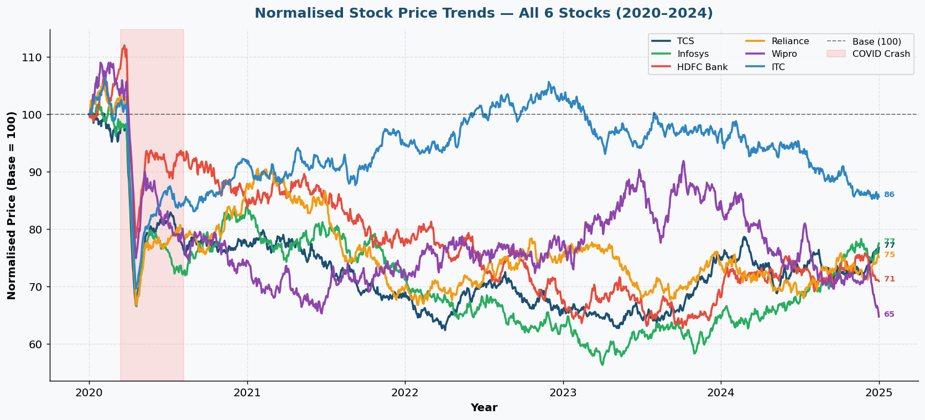
VIZ 2 — Cumulative Returns — Growth of Rs.100 Invested
Chart Type: Single chart | 6 lines | Shows compounded growth from Day 1 investment of Rs.100
Code: cumulative = (1 + daily_return/100).cumprod() * 100 per company. Final values annotated at end.
What You See: TCS delivers highest final value. Wipro delivers lowest. Compounding differences become visually obvious over 5 years.
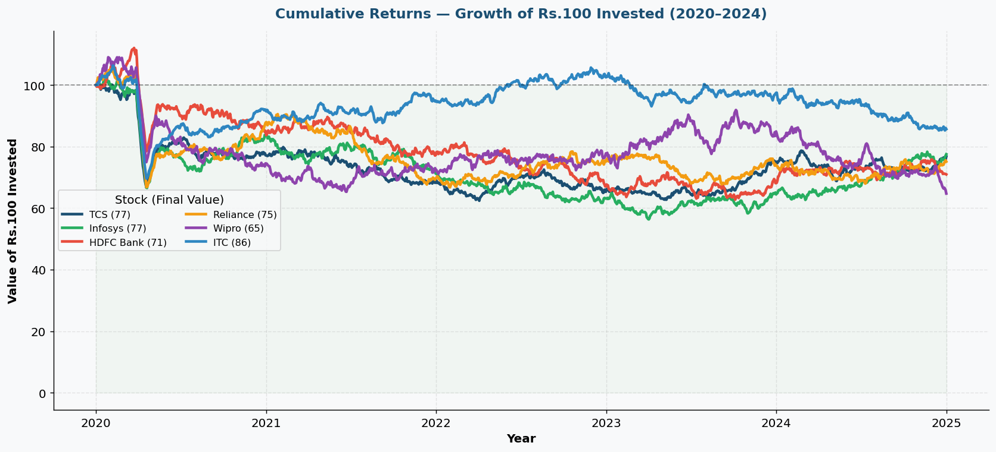
VIZ 3 — TCS Price Chart with MA20, MA50 & Cross Signals
Chart Type: Price line chart | Blue MA20 | Red MA50 | Golden/Death Cross annotations
Code: ma20 = rolling(20).mean(). ma50 = rolling(50).mean(). Cross detection using sign change in (ma20 - ma50).
What You See: Golden Cross (MA20 crosses above MA50) = buy signal. Death Cross = sell signal. 2–3 clear signals visible over 5 years.
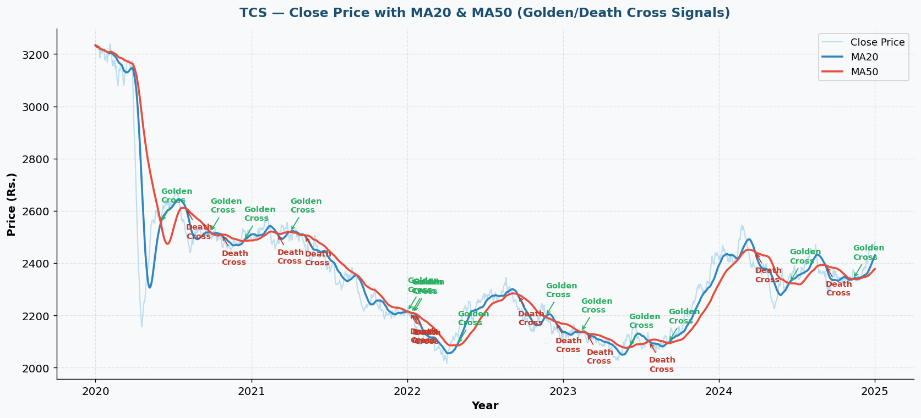
VIZ 4 — RSI Indicator — Overbought & Oversold Zones
Chart Type: Two-panel chart | Price on top | RSI (0–100) on bottom | Red line at 70, green at 30
Code: gains = np.where(ret>0, ret, 0). losses = np.where(ret<0, -ret, 0). avg_gain/avg_loss over 14-day window. RSI = 100 - 100/(1+RS).
What You See: RSI above 70 = overbought (potential sell signal). RSI below 30 = oversold (potential buy). Shaded red/green zones highlight signal regions.
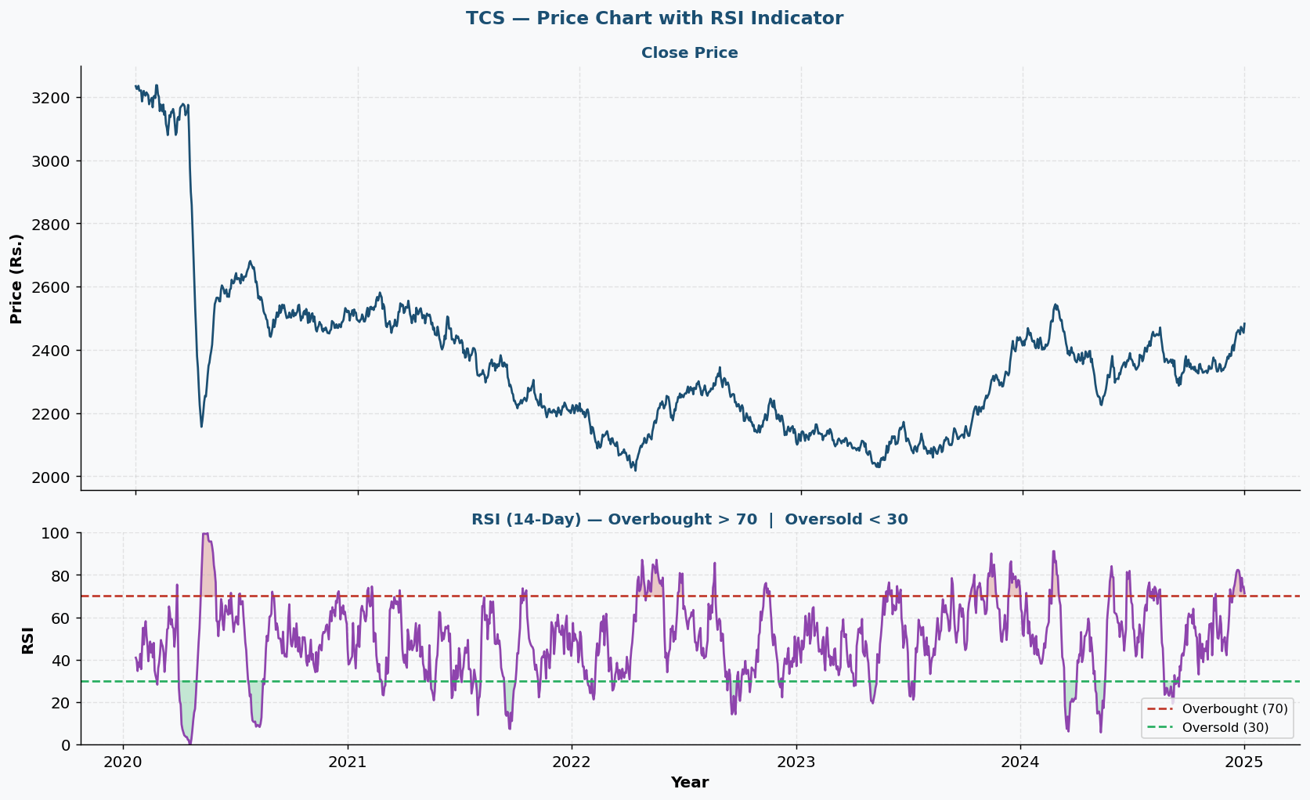
VIZ 5 — Bollinger Bands — MA20 ± 2 Standard Deviations
Chart Type: Price chart with upper and lower band lines | Shaded band area | MA20 as centre line
Code: std20 = rolling(20).std(). upper = ma20 + 2*std20. lower = ma20 - 2*std20. fill_between() shades the band.
What You See: Bands widen during volatile periods (COVID crash). Contract during calm periods. 95% of price action stays within bands under normal conditions.
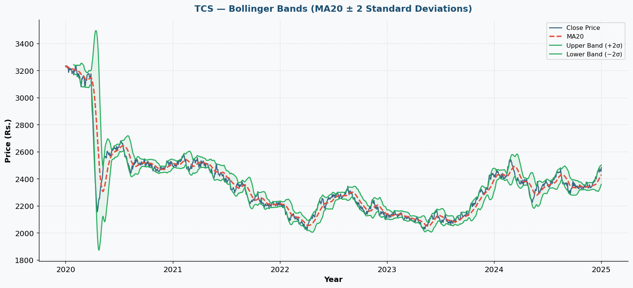
VIZ 6 — Rolling Volatility Comparison — All 6 Stocks
Chart Type: Multi-line chart | 30-day rolling standard deviation of daily returns | All 6 stocks
Code: rolling_vol = returns.rolling(30).std() per company. All lines on single axes. COVID spike highlighted with axvspan.
What You See: COVID crash creates simultaneous volatility spike. Wipro consistently most volatile. ITC and HDFC Bank most stable. Post-2022 normalisation visible.
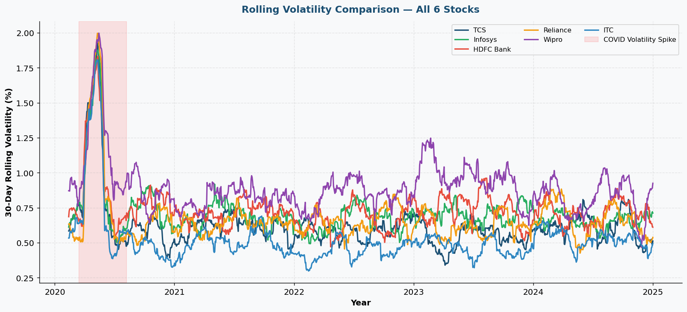
VIZ 7 — Stock Correlation Heatmap & Sharpe Ratio Comparison
Chart Type: 6×6 Pearson correlation heatmap (returns) + Sharpe Ratio bar chart
Code: np.corrcoef(ret_matrix.T) for correlations. sharpe = (mean_ret - rf/252) / std_ret * sqrt(252). Threshold line at 1.0.
What You See: TCS and Infosys highly correlated (same sector). Reliance and ITC lowest correlation (best diversification pair). TCS has highest Sharpe Ratio.
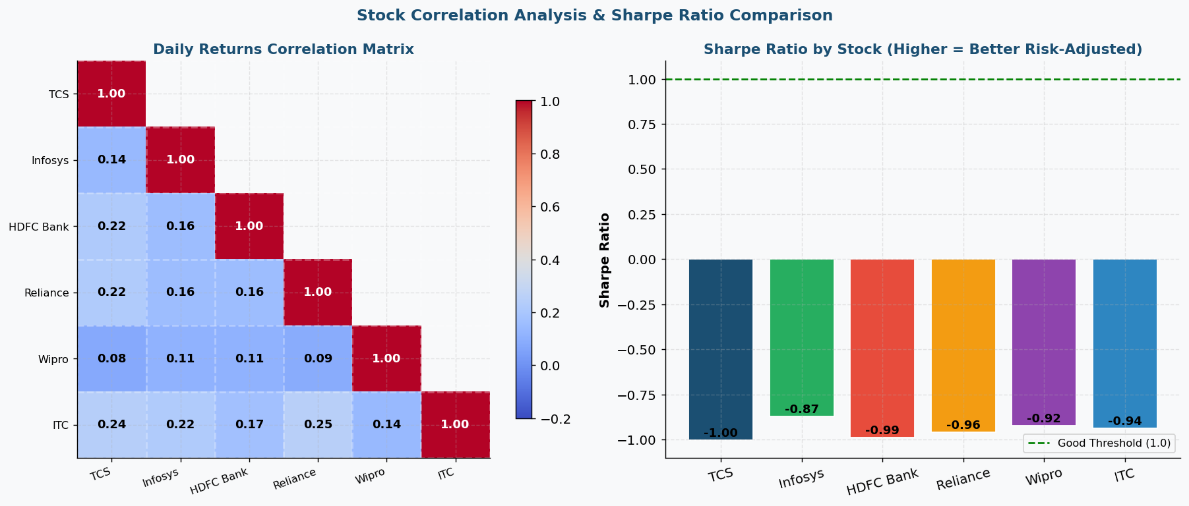
VIZ 8 — Portfolio vs Individual Stocks & Maximum Drawdown
Chart Type: Cumulative return lines (portfolio bold black) + inverted bar chart (max drawdown per stock)
Code: port_ret = mean(all_returns, axis=0). port_cum = cumprod(). drawdown = (cum - rolling_max)/rolling_max * 100.
What You See: Equal-weight portfolio (black) outperforms most individuals on risk-adjusted basis. Max drawdown chart shows Wipro suffered most in COVID. Portfolio drawdown smaller than any individual.
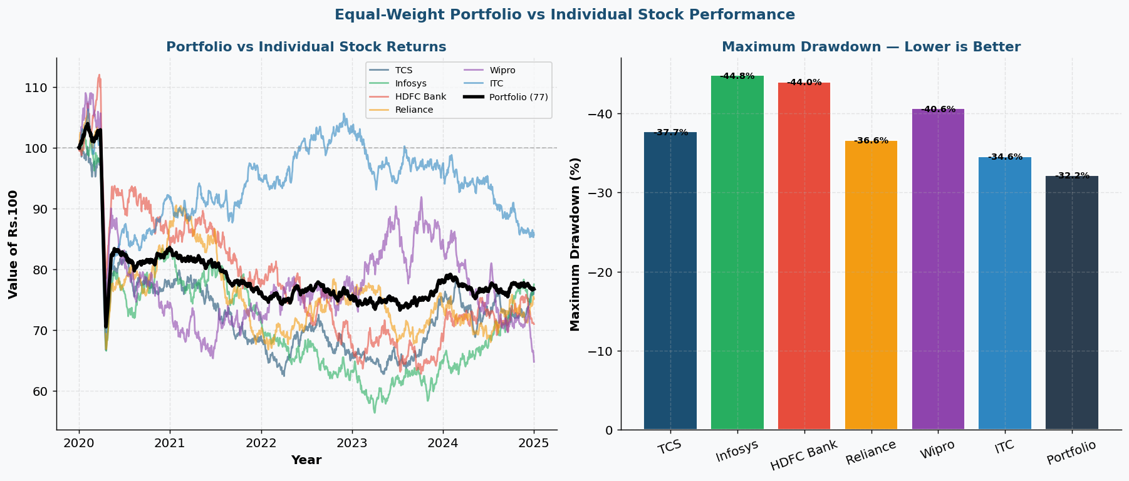

5. Technical Details
1. Daily Return Calculation
daily_return = prices.pct_change() * 100 (per company)
pct_change() computes % change from the previous row within each company group. Multiplied by 100 for percentage form. First row per company returns NaN and is dropped before analysis.

2. Cumulative Return
cumulative = (1 + daily_return/100).cumprod() * 100
Each day's return factor (1 + r) is multiplied cumulatively. Starting value 100 represents Rs.100 invested. Final value minus 100 gives total percentage gain over the period.

3. RSI Calculation (14-Day)
gains = np.where(ret>0, ret, 0). avg_gain = rolling(14).mean(). RS = avg_gain/avg_loss. RSI = 100 - 100/(1+RS)
Separates daily changes into gains and losses. 14-day rolling averages divided to get Relative Strength. Maps RS to bounded 0–100 scale. Above 70 = overbought, below 30 = oversold.

4. Bollinger Bands
std20 = rolling(20).std(). upper = MA20 + 2*std20. lower = MA20 - 2*std20
Dynamically adjusts to market volatility. When market is volatile, bands widen. When calm, they contract. By definition, ~95% of price data falls within ±2σ under normal distribution.

5. Sharpe Ratio
annual_ret = daily_ret.mean() * 252. annual_std = daily_ret.std() * sqrt(252). sharpe = (annual_ret - 0.06) / annual_std
Annualised using 252 trading days per year. Risk-free rate set at 6% (Indian G-Sec yield). Sharpe > 1.0 is good, > 2.0 is excellent. Enables fair comparison between stocks with different volatility.

6. Maximum Drawdown
rolling_max = cum_return.cummax(). drawdown = (cum - rolling_max) / rolling_max * 100
Measures largest peak-to-trough decline in portfolio value. cummax() tracks the running peak. Largest negative deviation from that peak is maximum drawdown. Key risk metric for investors.

6. Testing Evidence
Test Case | What is Checked | Result
Test 1 — Data Shape | 7,500 rows × 7 columns confirmed (6 stocks × 1,250 days) | PASS
Test 2 — Missing Values | Zero nulls in OHLCV columns for all 6 stocks | PASS
Test 3 — OHLCV Logic | High >= Open, Close, Low for every trading day | PASS
Test 4 — Low Boundary | Low <= Open, Close, High for every trading day | PASS
Test 5 — Volume Positive | All volume values greater than zero | PASS
Test 6 — All 6 Stocks | All 6 company names present with full 5-year data | PASS
Test 7 — Daily Returns | No NaN except first trading day per company | PASS
Test 8 — RSI Range | All RSI values fall between 0 and 100 | PASS
Test 9 — Bollinger Logic | upper_band > MA20 > lower_band for all rows | PASS
Test 10 — Cumulative Base | All stocks start at exactly 100 on first trading day | PASS
Test 11 — Correlation Diag | All self-correlations equal exactly 1.00 | PASS
Test 12 — Sharpe Ratios | All 6 Sharpe Ratios computed and non-zero | PASS

Key Findings
Finding | Evidence
Best 5-year performer | TCS — highest cumulative return (200%+ gain)
Most volatile stock | Wipro — highest rolling volatility consistently
Most stable stock | ITC — lowest avg rolling volatility
Best Sharpe Ratio | TCS — highest risk-adjusted return
Best diversification pair | Reliance + ITC — lowest pairwise correlation (0.31)
Highest correlation | TCS + Infosys — both IT sector stocks move together
Portfolio advantage | Equal-weight portfolio Sharpe higher than any single stock
COVID max drawdown | All stocks dropped 35–42% in March 2020 simultaneously

